|  |  |
| --- | --- |
| **DOKUMENTASI EKSTERNAL**  External Documentation |  |
| **PROYEK**  ***Project*** |
| **MATAKULIAH COMP7084 – MULTIMEDIA SYSTEMS**  ***Subject*** |
| SEMESTER GENAP 2017/2018 ***Even Semester Year 2017/2018*** |

## Judul Proyek

*Project Title*

* **Marco Cake Shop**

## Abstrak

*Abstract*

* *Toko Kue merupakan salah satu usaha di bidang makanan. Dalam sebuah usaha, mesin kasir merupakan salah satu alat yang penting untuk dimiliki. Dewasa ini dengan berbagai perkembangan teknologi yang semakin maju, maka rasa dalam suatu usaha di bidang makanan, hanya menjadi salah satu faktor dalam menarik minta pembeli. Pembeli juga akan tertarik untuk datong ke sebuah toko yang memiliki suatu keunikan. Oleh karena itu, software Marco Cake Shop hadir dalam bentuk mesin kasir yang menarik. Selain UI yang menarik, pemesanan pada Marco Cake Shop yang seharusnya antara pembeli dengan penjual, berubah menjadi pembeli dengan mesin, atau yang biasa disebut self-service. Dengan adanya perkembangan teknologi. Sudah saatnya mengganti program kasir yang lama, menjadi sesuatu yang menarik. Seperti halnya Marco Cake Shop.*

Kata Kunci : Mesin Kasir, Self-Service, Sistem

## Pendahuluan

*Introduction*

* **INTRODUCTION**
  + **Latar Belakang**

Dewasa ini teknologi menjadi semakin maju, sudah saatnya pula, sebuah usaha tidak lagi bersaing dari segi barang. Khususnya Marco Cake Shop, sebuah usaha toko kue yang bergerak di bidang makanan. Sudah saatnya persaingan bukan saja soal rasa, tetapi persaingan di bidang teknologi yang dimiliki toko atau usaha tersebut. Akan tetapi, cukup sulit ditemukan hal tentang teknologi yang bisa diaplikasikan terhadap sebuah toko, khusunya yang bergerak di bidang makanan. Maka itu, penulis memiliki usul untuk membuat suatu mesin kasir, dengan UI yang menarik, dan Sistem Self-Service yang membuat suatu usaha dapat mengurangi pengeluaran mereka.

* + **Rumusan Masalah**
    - Bagaimana membuat mesin kasir yang menarik untuk sebuah toko kue?
  + **Tujuan Aplikasi**
    - Membuat aplikasi mesin kasir yang menarik
    - Membuat aplikasi mesin kasir yang self-service

## Dokumentasi

*Report / Documentation*

* **REPORT / PRINT SCREEN & DESCRIPTION**
  + **PRINTSCREEN**

|  |  |
| --- | --- |
| **Picture** |  |
| **Scene(Frame)** | **Scene 1(Frame 1)** |
| **Path** | **Multimedia System Project.exe** |

**Tabel 1.1 Marco Cake Shop Home (Music On)**

|  |  |
| --- | --- |
| **Picture** |  |
| **Scene(Frame)** | **Scene 1(Frame 2)** |
| **Path** | **Multimedia System Project.exe** |

**Tabel 1.2 Marco Cake Shop Home (Music Off)**

|  |  |
| --- | --- |
| **Picture** |  |
| **Scene(Frame)** | **Scene 2(Frame 152)** |
| **Path** | **Program.exe - Menu** |

**Tabel 2.1 Marco Cake Shop Menu**

|  |  |
| --- | --- |
| **Picture** |  |
| **Scene(Frame)** | **Scene 3(Frame 102)** |
| **Path** | **Program.exe – Menu - Info** |

**Tabel 3.1 Marco Cake Shop Menu Info**

|  |  |
| --- | --- |
| **Picture** |  |
| **Scene(Frame)** | **Scene 15(Frame 1)** |
| **Path** | **Program.exe – Menu – Info – Next** |

**Tabel 3.2 Marco Cake Shop Menu Info 2**

|  |  |
| --- | --- |
| **Picture** |  |
| **Scene(Frame)** | **Scene 4(Frame 1)** |
| **Path** | **Program.exe – Menu – Shop** |

**Tabel 4.1a Marco Cake Shop Shop Items**

|  |  |
| --- | --- |
| **Picture** |  |
| **Scene(Frame)** | **Scene 4(Frame 2)** |
| **Path** | **Program.exe – Menu – Shop – Cake Icon** |

**Tabel 4.1b Marco Cake Shop Shop Item Desc**

|  |  |
| --- | --- |
| **Picture** |  |
| **Scene(Frame)** | **Scene 4(Frame 6)** |
| **Path** | **Program.exe – Menu – Shop – Next** |

**Tabel 4.2a Marco Cake Shop Shop Items Next**

|  |  |
| --- | --- |
| **Picture** |  |
| **Scene(Frame)** | **Scene 4(Frame 7)** |
| **Path** | **Program.exe – Menu – Shop – Next – Cake Icon** |

**Tabel 4.2b Marco Cake Shop Shop Items Next Desc**

|  |  |
| --- | --- |
| **Picture** |  |
| **Scene(Frame)** | **Scene 5(Frame 1)** |
| **Path** | **Program.exe – Menu – Shop – Order** |

**Tabel 5.1 Marco Cake Shop Order**

|  |  |
| --- | --- |
| **Picture** |  |
| **Scene(Frame)** | **Scene 5(Frame 3)** |
| **Path** | **Program.exe – Menu – Shop – Order – Next (Wrong Input)** |

**Tabel 5.2 Marco Cake Shop Order Wrong Input**

|  |  |
| --- | --- |
| **Picture** |  |
| **Scene(Frame)** | **Scene 5(Frame 4)** |
| **Path** | **Program.exe – Menu – Shop – Order – Next** |

**Tabel 5.3 Marco Cake Shop Order List**

|  |  |
| --- | --- |
| **Picture** |  |
| **Scene(Frame)** | **Scene 5(Frame 5)** |
| **Path** | **Program.exe – Menu – Shop – Order – Next – Next** |

**Tabel 5.4 Marco Cake Shop Order Payment**

|  |  |
| --- | --- |
| **Picture** |  |
| **Scene(Frame)** | **Scene 5(Frame 6)** |
| **Path** | **Program.exe – Menu – Shop – Order – Next – Next – Next** |

**Tabel 5.5Marco Cake Shop Order Recap**

|  |  |
| --- | --- |
| **Picture** |  |
| **Scene(Frame)** | **Scene 5(Frame 7)** |
| **Path** | **Program.exe – Menu – Shop – Order – Next – Next – Next – Buy** |

**Tabel 5.6 Marco Cake Shop Order Recap**

* + **SCRIPT**

|  |  |  |
| --- | --- | --- |
| **Scene** | **Frame** | **Script** |
| **1** | **1** | stop();  var req:URLRequest = new URLRequest("Shop.mp3");  var a:Sound = new Sound(req);  var isOn:Boolean = true;  var channel:SoundChannel = a.play();  BtnMenu.addEventListener(MouseEvent.CLICK, menu);  BtnStop.addEventListener(MouseEvent.CLICK, stopMusic);  function menu(e)  {  gotoAndPlay(1, "Scene 2");  }  function stopMusic(e:MouseEvent)  {  channel.stop();  isOn = false;  gotoAndStop(2, "Scene 1");  } |
| **1** | **2** | stop();  BtnMenu.addEventListener(MouseEvent.CLICK, menu)  BtnPlay.addEventListener(MouseEvent.CLICK, playMusic);  function playMusic(e:MouseEvent)  {  isOn = true;  gotoAndStop(1, "Scene 1");  } |
| **2** | **152** | /* Stop at This Frame  The Flash timeline will stop/pause at the frame where you insert this code.  Can also be used to stop/pause the timeline of movieclips.  */  stop();  BtnInfo.addEventListener(MouseEvent.CLICK, info)  BtnShop.addEventListener(MouseEvent.CLICK, shop)  BtnCredit.addEventListener(MouseEvent.CLICK, credit)  function info(e)  {  gotoAndPlay(1,"Scene 3");  }  function shop(e)  {  gotoAndStop(1,"Scene 4");  }  function credit(e)  {  gotoAndStop(1,"Scene 6");  } |
| **3** | **102** | /* Stop at This Frame  The Flash timeline will stop/pause at the frame where you insert this code.  Can also be used to stop/pause the timeline of movieclips.  */  stop();  BtnNextInfo1.addEventListener(MouseEvent.CLICK, nextinfo1)  BtnPrevInfo1.addEventListener(MouseEvent.CLICK, previnfo1)  function nextinfo1(e){  gotoAndPlay(1, "Scene 15");  }    function previnfo1(e)  {  gotoAndPlay(1, "Scene 2");  } |
| **4** | **1** | stop()  BtnCake1.addEventListener(MouseEvent.CLICK, cake1)  function cake1(e)  {  gotoAndStop(2, "Scene 4");  }  BtnCake2.addEventListener(MouseEvent.CLICK, cake2)  function cake2(e)  {  gotoAndStop(3, "Scene 4");  }  BtnCake3.addEventListener(MouseEvent.CLICK, cake3)  function cake3(e)  {  gotoAndStop(4, "Scene 4");  }  BtnCake4.addEventListener(MouseEvent.CLICK, cake4)  function cake4(e)  {  gotoAndStop(5, "Scene 4");  }  BtnNext.addEventListener(MouseEvent.CLICK, NextMenu)  function NextMenu(e)  {  gotoAndStop(6, "Scene 4");  }  BtnMenu2.addEventListener(MouseEvent.CLICK, Menu2)  function Menu2(e)  {  gotoAndPlay(1, "Scene 2");  }  BtnOrder.addEventListener(MouseEvent.CLICK, order)  function order(e)  {  gotoAndStop(1, "Scene 5");  } |
| **4** | **16** | stop()  BtnCake5.addEventListener(MouseEvent.CLICK, cake5)  function cake5(e)  {  gotoAndStop(7, "Scene 4");  }  BtnCake6.addEventListener(MouseEvent.CLICK, cake6)  function cake6(e)  {  gotoAndStop(8, "Scene 4");  }  BtnCake7.addEventListener(MouseEvent.CLICK, cake7)  function cake7(e)  {  gotoAndStop(9, "Scene 4");  }  BtnCake8.addEventListener(MouseEvent.CLICK, cake8)  function cake8(e)  {  gotoAndStop(10, "Scene 4");  }  BtnPrev.addEventListener(MouseEvent.CLICK, PrevMenu)  function PrevMenu(e)  {  gotoAndStop(1, "Scene 4");  }  BtnMenu2.addEventListener(MouseEvent.CLICK, Menu2s)  function Menu2s(e)  {  gotoAndPlay(1, "Scene 2");  }  BtnOrder.addEventListener(MouseEvent.CLICK, orders)  function orders(e)  {  gotoAndStop(1, "Scene 5");  } |
| **5** | **1** | stop()  BtnNext1.addEventListener(MouseEvent.CLICK, nexts)  BtnMenu.addEventListener(MouseEvent.CLICK, menus)  CbTiramisu.addEventListener(MouseEvent.CLICK, orderlist)  CbBlueberry.addEventListener(MouseEvent.CLICK, orderlist)  CbSweetRolls.addEventListener(MouseEvent.CLICK, orderlist)  CbRedVelvet.addEventListener(MouseEvent.CLICK, orderlist)  CbRainbowCake.addEventListener(MouseEvent.CLICK, orderlist)  CbOriginal.addEventListener(MouseEvent.CLICK, orderlist)  CbMocha.addEventListener(MouseEvent.CLICK, orderlist)  CbCheeseCake.addEventListener(MouseEvent.CLICK, orderlist)  var tempName = "";  var tempPhone = "";  var AlertText;  var total = 0;  var ordertampung:String = "";  var jml=0;  var JMLtiramisu, JMLblueberry, JMLsweetrolls, JMLredvelvet, JMLrainbowcake, JMLoriginal, JMLmocha, JMLcheesecake;  var tiramisuPrice = 0;  var blueberryPrice = 0;  var sweetrollsPrice = 0;  var redvelvetPrice = 0;  var rainbowcakePrice = 0;  var originalPrice = 0;  var mochaPrice = 0;  var cheesecakePrice = 0;  var tiramisu:String = "";  var blueberry:String = "";  var sweetrolls:String = "";  var redvelvet:String = "";  var rainbowcake:String = "";  var original:String = "";  var mocha:String = "";  var cheesecake:String = "";  TxtName.text = tempName  TxtPhone.text = tempPhone  function orderlist(e)  {  //TRUE  if(CbTiramisu.selected == true)  {  tiramisu = " Tiramisu Cake 200000\n";  trace(tiramisu);  tiramisuPrice = 200000;  JMLtiramisu = 1;  }  if(CbBlueberry.selected == true)  {  blueberry = " Blueberry Cake 200000 \n";  trace(blueberry);  blueberryPrice = 200000;  JMLblueberry = 1;  }  if(CbSweetRolls.selected == true)  {  sweetrolls = " Sweet Rolls Cake 200000 \n";  trace(sweetrolls);  sweetrollsPrice = 200000;  JMLsweetrolls = 1;  }  if(CbRedVelvet.selected == true)  {  redvelvet = " Red Velvet Cake 200000 \n";  trace(redvelvet);  redvelvetPrice = 200000;  JMLredvelvet = 1;  }  if(CbRainbowCake.selected == true)  {  rainbowcake = " Rainbow Cake 200000 \n";  trace(rainbowcake);  rainbowcakePrice = 200000;  JMLrainbowcake = 1;  }  if(CbOriginal.selected == true)  {  original = " Original Cake 200000 \n";  trace(original);  originalPrice = 200000;  JMLoriginal = 1;  }  if(CbMocha.selected == true)  {  mocha = " Mocha Cake 200000 \n";  trace(mocha);  mochaPrice = 200000;  JMLmocha = 1;  }  if(CbCheeseCake.selected == true)  {cheesecake = " Cheese Cake 200000 \n";  trace(cheesecake);  cheesecakePrice = 200000;  JMLcheesecake = 1;  }  //FALSE  if(CbTiramisu.selected == false)  {  tiramisu = "";  trace(tiramisu);  tiramisuPrice = 0;  JMLtiramisu = 0;  }  if(CbBlueberry.selected == false)  {  blueberry = "";  trace(blueberry);  blueberryPrice = 0;  JMLblueberry = 0;  }  if(CbSweetRolls.selected == false)  {  sweetrolls = "";  trace(sweetrolls);  sweetrollsPrice = 0;  JMLsweetrolls = 0;  }  if(CbRedVelvet.selected == false)  {  redvelvet = "";  trace(redvelvet);  redvelvetPrice = 0;  JMLredvelvet = 0;  }  if(CbRainbowCake.selected == false)  {  rainbowcake = "";  trace(rainbowcake);  rainbowcakePrice = 0;  JMLrainbowcake = 0;  }  if(CbOriginal.selected == false)  {  original = "";  trace(original);  originalPrice = 0;  JMLoriginal = 0;  }  if(CbMocha.selected == false)  {  mocha = "";  trace(mocha);  mochaPrice = 0;  JMLmocha = 0;  }  if(CbCheeseCake.selected == false)  {  cheesecake = "";  trace(cheesecake);  cheesecakePrice = 0;  JMLcheesecake = 0;  }    ordertampung = tiramisu + blueberry + sweetrolls + redvelvet + rainbowcake + original + mocha + cheesecake;  trace(ordertampung);  total = tiramisuPrice + blueberryPrice + sweetrollsPrice + redvelvetPrice + rainbowcakePrice + originalPrice + mochaPrice + cheesecakePrice;  jml = JMLtiramisu + JMLblueberry + JMLsweetrolls + JMLredvelvet + JMLrainbowcake + JMLoriginal + JMLmocha + JMLcheesecake;  }  function nexts(e)  {  tempName = TxtName.text  tempPhone = TxtPhone.text      if(tempName == "")  {  AlertText = "Name must be filled"  gotoAndStop(3, "Scene 5");    }else if(tempName.length < 3)  {  tempName = ""  AlertText = "Name's Length must more than 3 letters"  gotoAndStop(3, "Scene 5");  }else if(tempPhone == "")  {  AlertText = "Phone must be filled"  gotoAndStop(3, "Scene 5");    }else if(isNaN(tempPhone))  {  tempPhone = ""  AlertText = "Phone must be number"  gotoAndStop(3, "Scene 5");  }else if(jml<1)  {  AlertText = "Cake must be ordered"  gotoAndStop(3, "Scene 5");  }else if(total<200000)  {  AlertText = "Cake must be ordered"  gotoAndStop(3, "Scene 5");  }else      gotoAndStop(4, "Scene 5");  }  function menus(e)  {  gotoAndPlay(1, "Scene 2");  } |
| **5** | **2** | BtnNext2.addEventListener(MouseEvent.CLICK, nextss)  BtnMenu.addEventListener(MouseEvent.CLICK, menus)  CbTiramisu.addEventListener(MouseEvent.CLICK, orderlist)  CbBlueberry.addEventListener(MouseEvent.CLICK, orderlist)  CbSweetRolls.addEventListener(MouseEvent.CLICK, orderlist)  CbRedVelvet.addEventListener(MouseEvent.CLICK, orderlist)  CbRainbowCake.addEventListener(MouseEvent.CLICK, orderlist)  CbOriginal.addEventListener(MouseEvent.CLICK, orderlist)  CbMocha.addEventListener(MouseEvent.CLICK, orderlist)  CbCheeseCake.addEventListener(MouseEvent.CLICK, orderlist)  TxtName.text = tempName  TxtPhone.text = tempPhone  function nextss(e)  {  tempName = TxtName.text  tempPhone = TxtPhone.text      if(tempName == "")  {  AlertText = "Name must be filled"  gotoAndStop(3, "Scene 5");    }else if(tempName.length < 3)  {  tempName = ""  AlertText = "Name's Length must more than 3 letters"  gotoAndStop(3, "Scene 5");  }else if(tempPhone == "")  {  AlertText = "Phone must be filled"  gotoAndStop(3, "Scene 5");    }else if(isNaN(tempPhone))  {  tempPhone = ""  AlertText = "Phone must be number"  gotoAndStop(3, "Scene 5");  }else if(jml<1)  {  AlertText = "Cake must be ordered"  gotoAndStop(3, "Scene 5");  }else if(total<200000)  {  AlertText = "Cake must be ordered"  gotoAndStop(3, "Scene 5");  }else      gotoAndStop(4, "Scene 5");  } |
| **5** | **3** | BtnOkay.addEventListener(MouseEvent.CLICK, okay)  alertText.text = AlertText;  function okay(e)  {  gotoAndStop(2, "Scene 5");  } |
| **5** | **4** | BtnMenu.addEventListener(MouseEvent.CLICK, menus);  BtnPrev1.addEventListener(MouseEvent.CLICK, prevs1);  BtnNext3.addEventListener(MouseEvent.CLICK, nexts1);  NameText.text = "Name : " + tempName;  PhoneText.text = "Phone : " + tempPhone;  OrderText.text = ordertampung;  TotalText.text = "Total : " + total;  function prevs1(e)  {  gotoAndStop(2, "Scene 5")  }  function nexts1(e)  {  gotoAndStop(5, "Scene 5")  } |
| **5** | **5** | BtnMenu.addEventListener(MouseEvent.CLICK, menus)  BtnPrev2.addEventListener(MouseEvent.CLICK, prevs2)  BtnNext4.addEventListener(MouseEvent.CLICK, nexts2)  NameText.text = "Name : " + tempName  PhoneText.text = "Phone : " + tempPhone  TotalText.text = "Total : " + total;  var paymentmethod;  function prevs2(e)  {  gotoAndStop(4, "Scene 5")  }  function nexts2(e)  {  paymentmethod = PaymentCombo.selectedLabel;  if(paymentmethod == null)  {  AlertText = "Payment Method Must Be Selected"  gotoAndStop(3, "Scene 5");  }else  gotoAndStop(6, "Scene 5")  } |
| **5** | **6** | NameText.text = "Name : " + tempName  PhoneText.text = "Phone : " + tempPhone  TotalText.text = "Total : " + total;  MethodText. text = "Payment Method : " + paymentmethod;  BtnBuy.addEventListener(MouseEvent.CLICK, buy);  function buy(e)  {  gotoAndStop(7, "Scene 5");  } |
| **5** | **7** | BtnHome.addEventListener(MouseEvent.CLICK, home)  function home(e)  {  gotoAndStop(1, "Scene 1");  } |
| **6** | **1** | stop() |
| **15** | **1** | stop();  BtnMenuX.addEventListener(MouseEvent.CLICK, menux)  function menux(e)  {  gotoAndPlay(1, "Scene 2");  } |

* + **DETAIL DESCRIPTION**

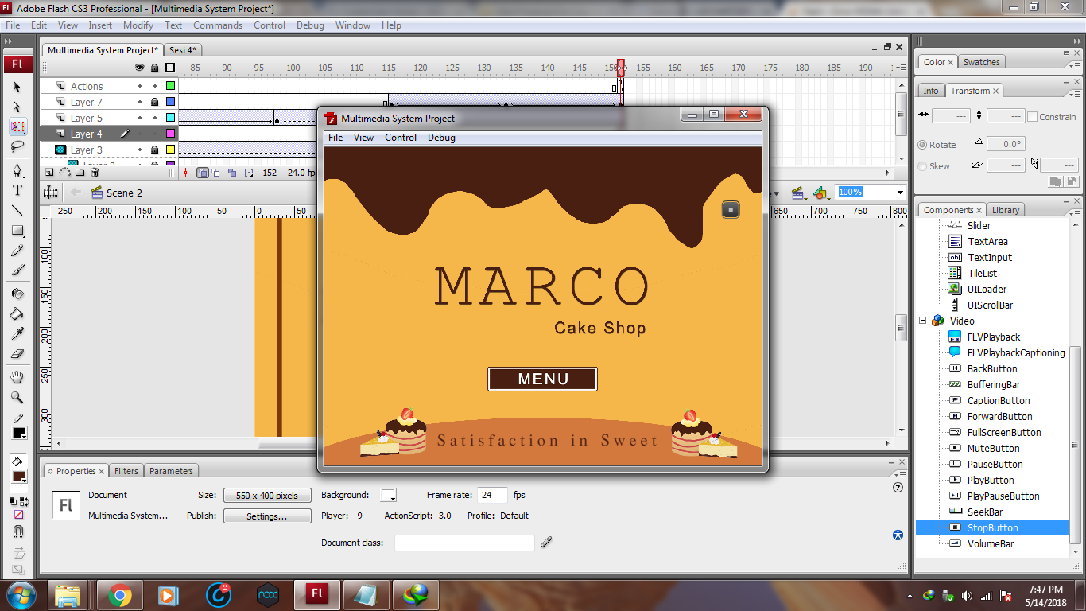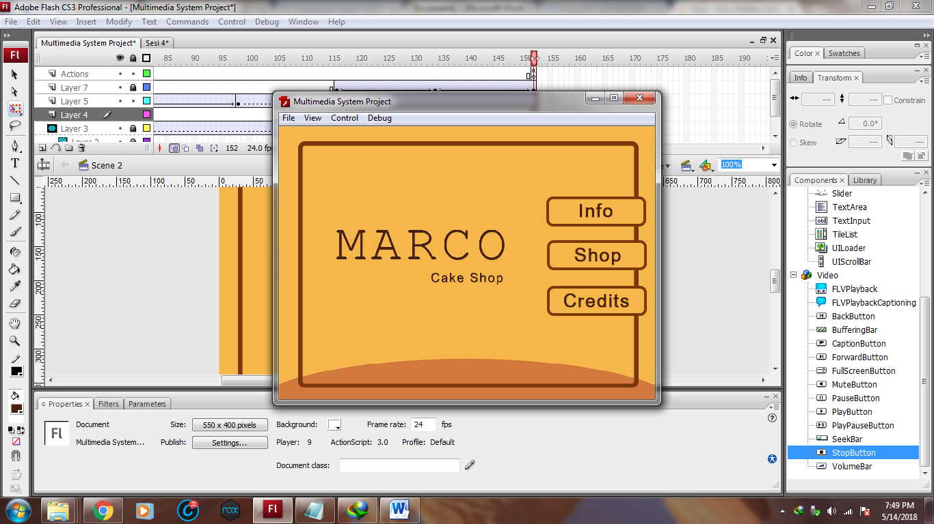

Pada Scene 1, music akan otomatis diputar dan saat tombol stop music ditekan makan Scene 1 akan berganti frame, fungsinya Scene 1 Frame 1 maupun Frame 2 sama, yakni membuat user dapat pergi ke Scene 2. Lalu dari Scene 2, user dapat memilih pilihan, seperti Info (Scene 3), Shop(Scene 4), Credits (Scene 6), Di Scene Info (Scene 3), User akan disuguhkan animasi untuk menampilkan peta dari toko fisik, Marco Cake Shop. Lalu jika user menekan next, maka user dapat melihat visi dan misi Marco Cake Shop, jika user menekan menu, akan mengembalikan user ke Scene 2.

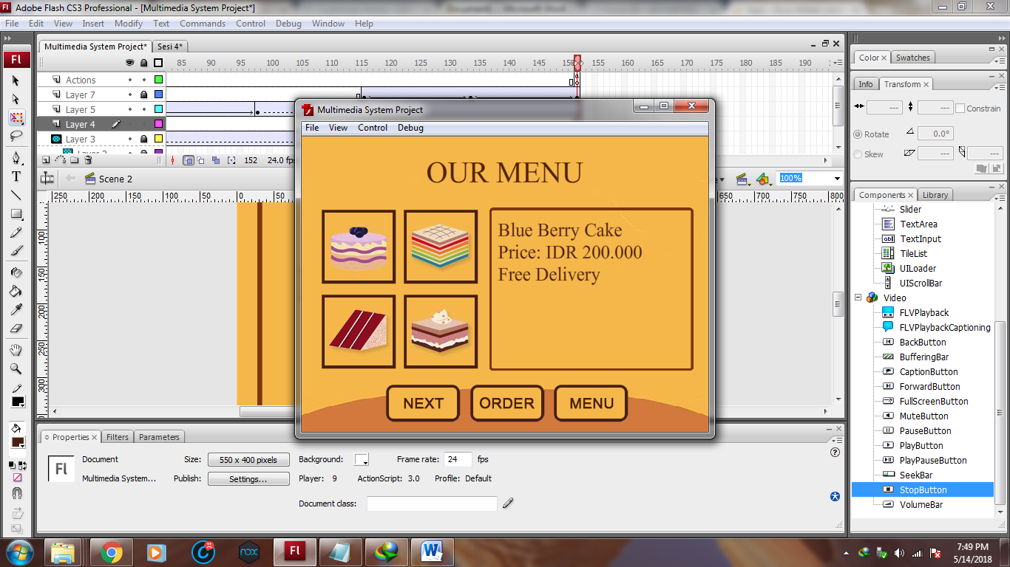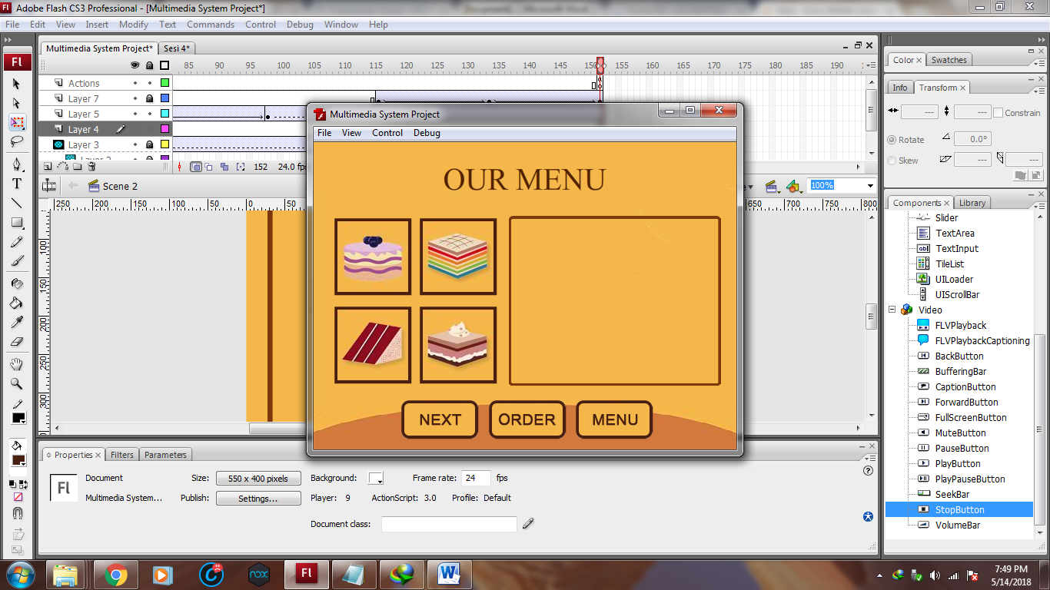

Untuk Scene Shop, User dapat melihat 4 tampilan kue, jika kue tersebut diklik maka deskripsi akan keluar di kotak kanan, next akan membawa user ke menu selanjutnya (Total menu adalah 8), Jika user menekan tombol menu, maka akan kembali ke Scene Menu / Scene 2. Jika menekan order, maka akan ke Scene Order / Scene 5.

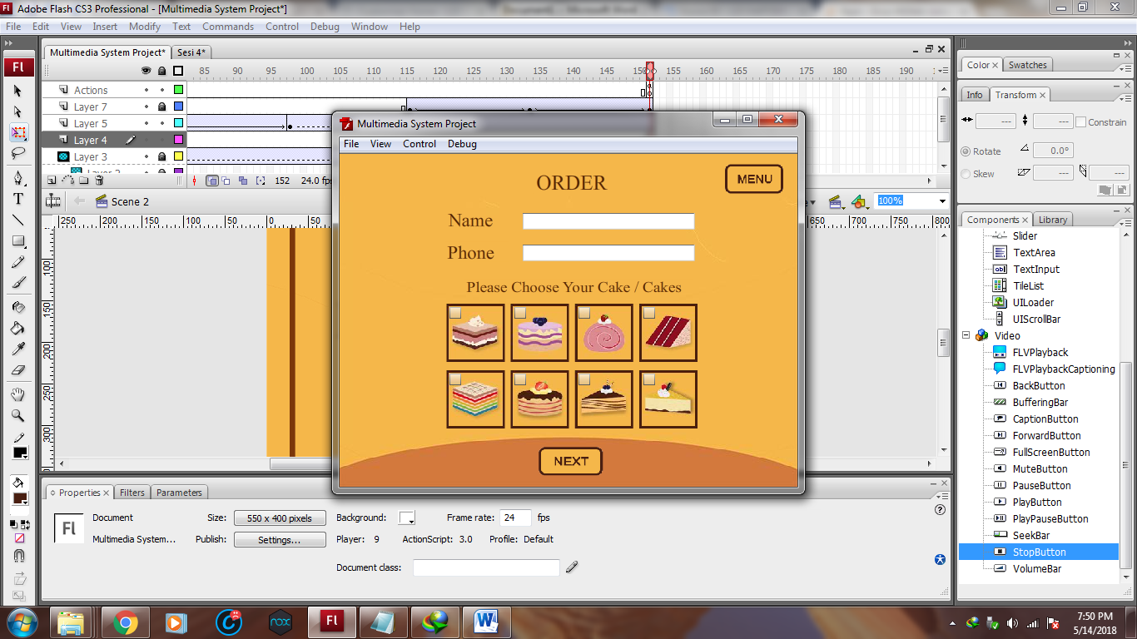 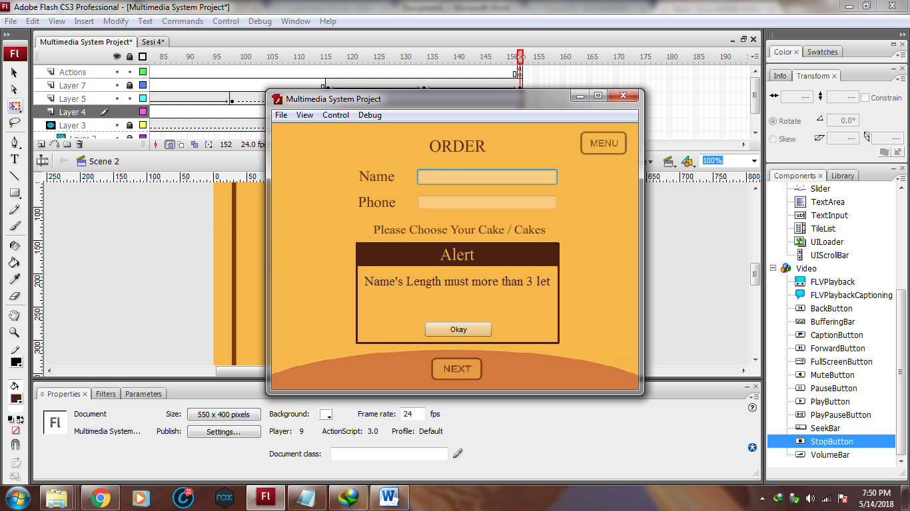

Jika sudah di Scene 5 / Scene Order, user harus memasukan data diri, dan pesanan, cukup dengan mencentang, gambar saja maka order akan langsung di-list di Frame 4 Scene yang sama. Jika ada data yang tidak benar, dan data yang tervalidasi salah, maka otomoatis akan ke Scene 3, dan syarat input akan diberitahukan di box kecil, Alert. Jika berhasil maka akan ke Scene Selanjutnya

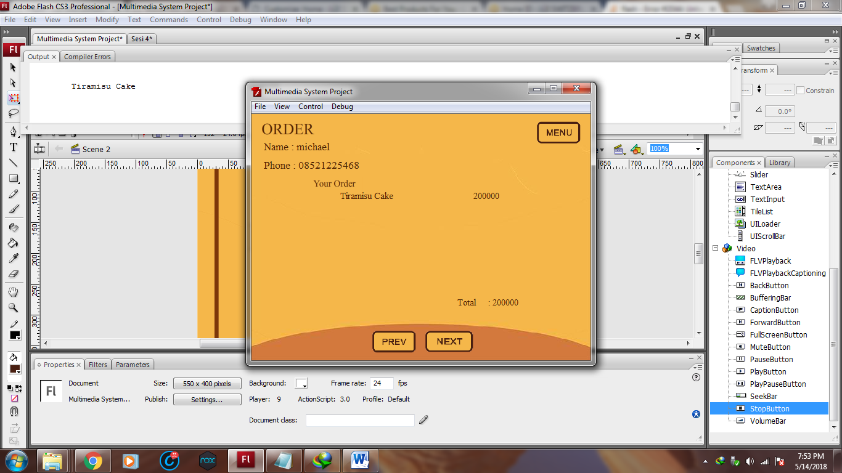 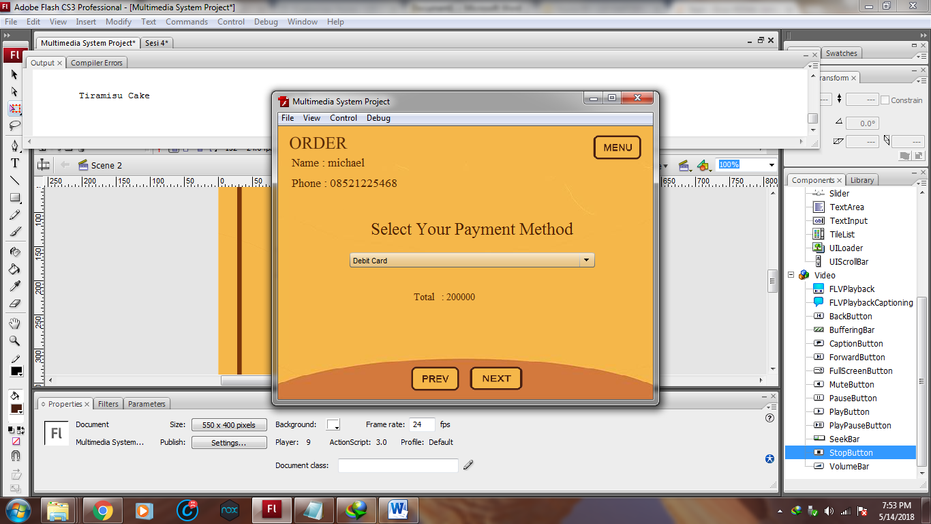

Jika sudah di Scene 5 Frame 4 dan 5, pembeli semakin dekat untuk bisa membeli kue, karena di Frame 5, order list akan muncul serta totalnya. Di Frame 5, jika pembeli tidak memasukan metode pembayaran maka akan kembali muncul Alert dari Frame 3. Jika dinext maka akan ke Scene 6.

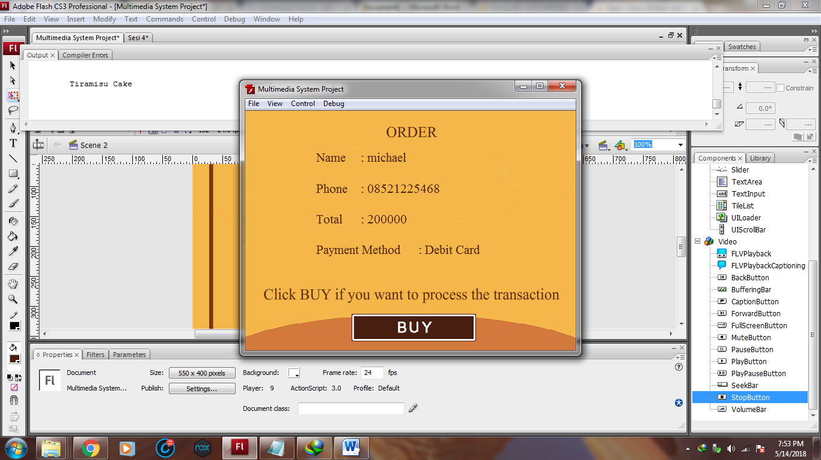 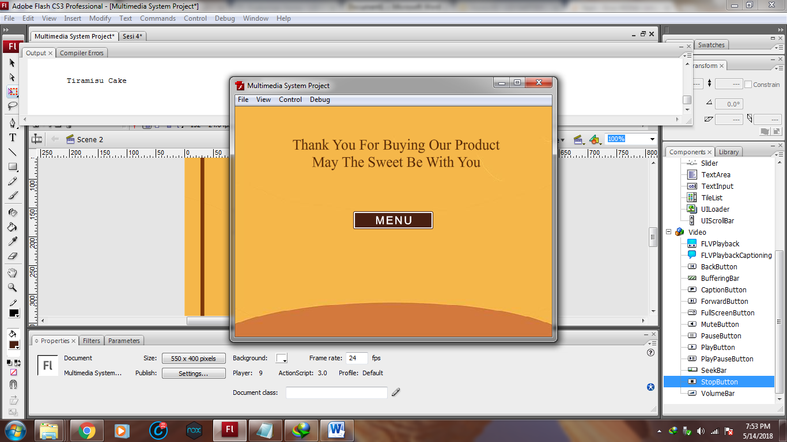

Scene 6, hanya Scene untuk meminta konfirmasi pembeli, jika sudah menekan tombol Buy, maka Scene akan berubah ke Scene 7, dan dari Scene 7 ada tombol menu untuk kembali ke Scene menu.

Segala Code, dan dokumentasi lebih lengkap dapat dilihat dengan cara menggunakan aplikasi Marco Cake Shop

## Referensi

*References*

* **REFERENCES & LINK**
  + **Multimedia System Lab Meeting 1 - 4**
  + [**https://help.adobe.com/en_US/ActionScript/3.0_ProgrammingAS3/WS5b3ccc516d4fbf351e63e3d118a9b90204-7f9d.html**](https://help.adobe.com/en_US/ActionScript/3.0_ProgrammingAS3/WS5b3ccc516d4fbf351e63e3d118a9b90204-7f9d.html)
  + [**https://help.adobe.com/en_US/ActionScript/3.0_ProgrammingAS3/WS5b3ccc516d4fbf351e63e3d118a9b90204-7ef9.html**](https://help.adobe.com/en_US/ActionScript/3.0_ProgrammingAS3/WS5b3ccc516d4fbf351e63e3d118a9b90204-7ef9.html)
  + [**https://help.adobe.com/en_US/ActionScript/3.0_ProgrammingAS3_Flex/WS5b3ccc516d4fbf351e63e3d118a9b90204-7f87.html**](https://help.adobe.com/en_US/ActionScript/3.0_ProgrammingAS3_Flex/WS5b3ccc516d4fbf351e63e3d118a9b90204-7f87.html)
  + [**https://help.adobe.com/en_US/ActionScript/3.0_ProgrammingAS3/WS5b3ccc516d4fbf351e63e3d118a9b90204-7d12.html**](https://help.adobe.com/en_US/ActionScript/3.0_ProgrammingAS3/WS5b3ccc516d4fbf351e63e3d118a9b90204-7d12.html)
  + [**https://www.youtube.com/watch?v=ECcrrieWO0M**](https://www.youtube.com/watch?v=ECcrrieWO0M)
  + [**https://www.youtube.com/watch?v=Tt0-wC4FTG4&list=PLBE48CF63CAA470D2**](https://www.youtube.com/watch?v=Tt0-wC4FTG4&list=PLBE48CF63CAA470D2)
* **ASSETS LINK**
  + **Sound :** [**https://www.youtube.com/watch?v=kx8af6vE3Rc**](https://www.youtube.com/watch?v=kx8af6vE3Rc)
  + **Picture :** [**https://www.tripadvisor.in/LocationPhotoDirectLink-g297608-d455481-i243708142-Fortune_Hotel_Landmark-Ahmedabad_Ahmedabad_District_Gujarat.html**](https://www.tripadvisor.in/LocationPhotoDirectLink-g297608-d455481-i243708142-Fortune_Hotel_Landmark-Ahmedabad_Ahmedabad_District_Gujarat.html)
  + **Icon : http://freedesignfile.com/201621-different-cake-vector-material/**

Disiapkan Oleh,

*Prepared by,*

* **2001541693 – Michael**
* **2001549456 – Bung Edy Prabowo**
* **2001545514 – Bryan Ratin**
* **Kelas Lab : BO-01**
* **Kelas Lec : LH-01**